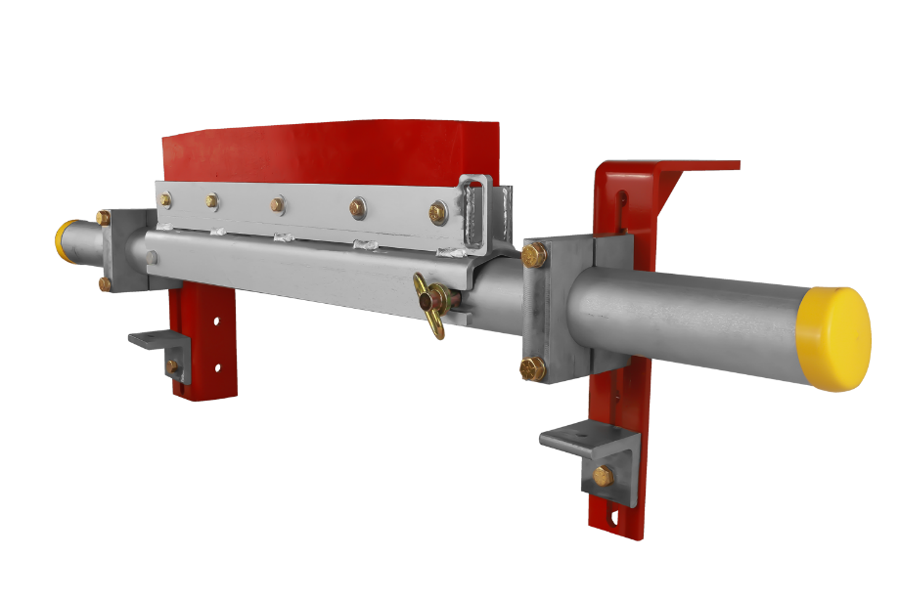[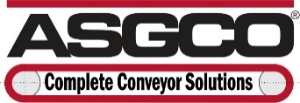](http://www.asgco.com/)Media Contact:

Taylor Olszyk – ASGCO® (610) 778-8908

[Tolszyk@asgco.com](mailto:Tolszyk@asgco.com)

ASGCO® – “Complete Conveyor Solutions”

For Immediate Release

August 1st, 2025

**ASGCO® Announces New Razor-Back® CSB Series– Secondary Belt Cleaner!**

Nazareth, PA.: ASGCO® “Complete Conveyor Solutions” announces the latest addition to their line of conveyor belt products that enhance efficiency, safety, and productivity. The New Razor-Back® CSB series by ASGCO® is a versatile line of primary belt cleaners engineered to improve conveyor efficiency by effectively removing carryback at the head pulley, helping to prevent material buildup, reduce maintenance, and extend conveyor component life.

**ASGCO® Razor-Back® CSB series** is specifically designed to improve belt cleaner safety, reliability, and ease of maintenance. The CSB lineup includes multiple models tailored to meet a wide range of operational demands, from compact, space-saving installations to heavy-duty, high-tonnage applications in the most demanding environments. Each model in the CSB family can be paired with a precision-engineered spring tensioning system that maintains consistent blade-to-belt pressure, ensuring optimal and sustained cleaning performance over time. These cleaners are available with a variety of blade options, including long-wearing polyurethane and high-performance tungsten carbide, to suit different materials and conditions. With a modular, field-friendly design and rugged construction, Razor-Back® CSB cleaners are built to deliver dependable performance, improve workplace safety, and maximize conveyor uptime. Whether your operation demands simplicity, advanced accessibility, or heavy-duty durability, there’s a Razor-Back® CSB solution engineered to meet your needs.

**About ASGCO®**

ASGCO® “Complete Conveyor Solutions” founded in 1971 and headquartered in Nazareth, PA is a leading manufacturer, distributor, and service provider of proprietary conveyor equipment and accessories that improve the safety and performance of bulk material handling systems.

ASGCO® is a diversified and innovative company with three major divisions that serve specific targets of the material handling industry. The growth of the company over the years is due to recognized improvements in the efficiency, safety, and productivity of our customers’ operations. At ASGCO®, we continue to strive to make the handling of bulk materials more efficient, safer, and more productive.

Visit our website at www.asgco.com. Contact us toll-free at (800) 344-4000 or [info@asgco.com](mailto:info@asgco.com)